WELCOME
TO
BELLAGHY PRIMARY
SCHOOL

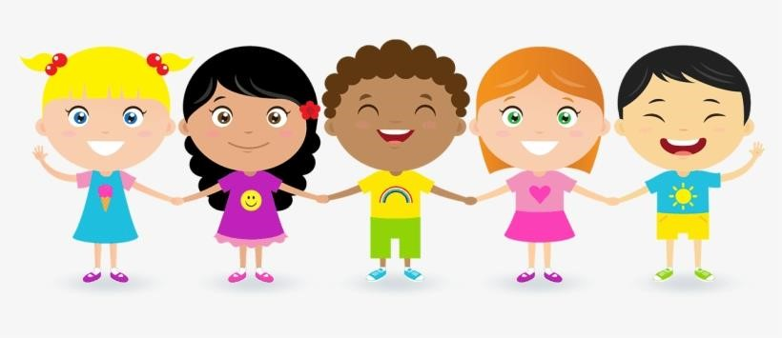

WELCOME TO BELLAGHY PRIMARY SCHOOL

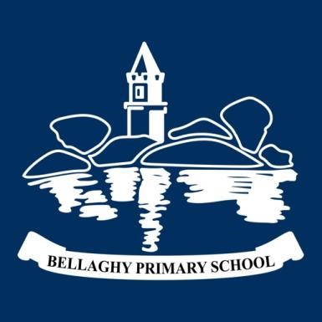
where ‘children come first.’
Thank you for considering Bellaghy Primary School for your child. We are very proud of our school which, although small in size, is very big in personality.

We are fully committed to our mission statement which is:

‘to provide, in partnership with parents, a broad, quality education so that all pupils can reach their full potential within a caring, supportive
environment promoting self-discipline, motivation and individuality.’

This booklet is designed to give you some basic information about life at Bellaghy Primary School.

OVERVIEW

Bellaghy Primary School is a small village school situated on the outskirts of the County Londonderry village. The school has an impressive building which has been exceptionally well maintained and contains large wellresourced classrooms, Resource area, Assembly Hall and recently refurbished bathrooms.

The grounds surrounding our school are extensive. At break and lunch times, our children have access to a large tarmac play area and when the weather is favourable, there are several green areas for the children to enjoy. We also have an outdoor classroom where we can take the learning out to the great outdoors!

Bellaghy Primary has a very positive ethos...we are basically one big happy family! That is indeed one of our primary aims...we want our children to learn and to achieve their full potential in a happy, supportive and caring environment where positive interpersonal relationships are paramount. High standards of behaviour are expected at our school and we consistently encourage self-respect and respect for others.
In addition, we aim to establish a positive relationship with our parents where they are encouraged to feel part of the school community. We believe that parents and teachers working together for the good of the children can enhance the educational experience for each child.

THE CURRICULUM

At Bellaghy Primary School, you can be certain that your child will receive a broad and balanced education based on the Northern Ireland Curriculum. In addition, our curriculum goes beyond what is laid down in statutory requirements. We strive to give our children opportunities to participate in educational visits, perform on stage, participate in after school activities and take part in cultural pursuits.

In essence, the school community at Bellaghy Primary School seeks to recognise and celebrate the special worth and talents of each child, developing that individual to his/her full potential.

CLASSES FOR 2021-22

P1 – P2 … 16 children – Mrs Richmond. (Principal Release – Mrs Quinn)
P3 – P4 … 13 children – Mrs Cameron
P5 – P7 … 17 children – Mrs Torrens
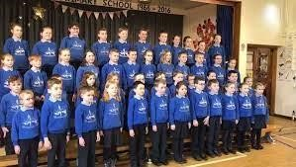

SCHOOL UNIFORM

All children wear uniform

Boys – Pale blue polo shirt Girls – Pale blue polo shirt Blue sweatshirt with Blue Sweatshirt with
school crest school crest
Navy trousers Navy skirt or pinafore or trousers
Summer Uniform
Boys – Pale blue polo shirt Girls – Pale blue checked
Navy shorts dress
SCHOOL UNIFORM - AVAILABLE FROM SELECT KIDZ, MAGHERAFELT SCHOOL HOODIES – AVAILABLE FROM SCHOOL

THE SCHOOL DAY
Early Birds Club – from 8.15am - £1 per day
School starts at 8.55am
Break – 10.45 – 11am
Lunch – 12.15 – 12.50pm
P1 – P2 – Home time – 2pm
P3 – P7 - Home time – 3pm
School closes for all children on Friday at 2pm

AFTER SCHOOL CHILDCARE CLUBS

2 o’clock club – this is an after-school club for P1 – P2 children whose parents wish them to stay in school until 3 o’clock – Monday - Thursday. To avail of 2 o’clock club, parents can pay £2 per day.

Hub Club – This is an after-school club which runs from 3pm – 5.30pm daily – Monday – Thursday. The charge is £5 per hour or part thereof.

You will be invoiced monthly for both these clubs. Please note, we are registered for the Childcare Voucher Scheme.

WHAT YOUR CHILD NEEDS FOR SCHOOL

A School Bag

A lunch box/bag
- Most children carry their snack and lunch in a lunch box/bag
- Please make sure your child can open and close his/her lunch box/bag

A water bottle

A coat

P.E Kit
  - P.E. uniform – trainers and dark coloured tracksuit bottoms or joggers which can be worn to school on P.E days
  - P5 – P7 will attend swimming lessons at Greenvale Leisure Centre every Thursday morning. More details will follow.

Your child will be given a Blue Book Bag with the school crest on it. He/she will carry this bag to and from school daily. Inside will be his/her reading book, diary and any other books needed for homework.

Your child does not need a pencil case. Each child has an individual pencil pot with pencils, eraser, scissors etc supplied by school. We just ask that you provide a Pritt Glue Stick which can stay in school.

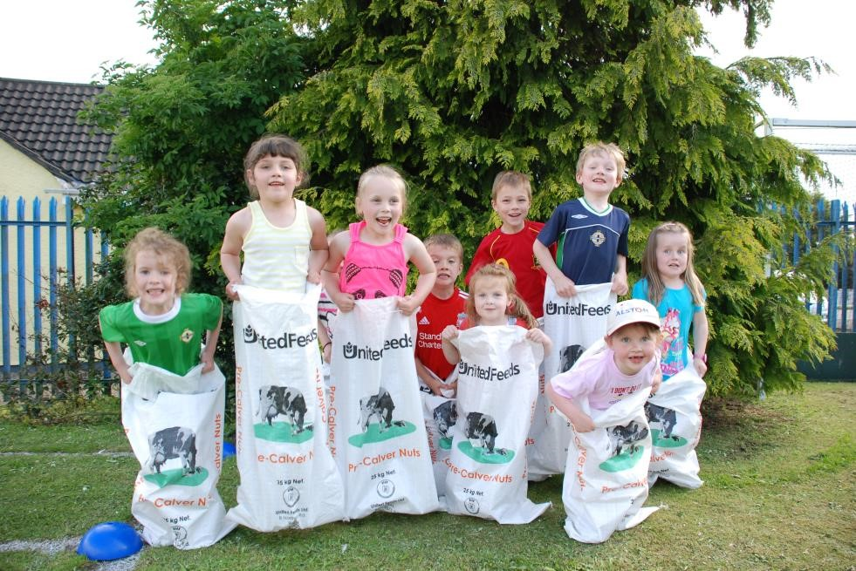

BREAK AND LUNCH

We have our morning break at 10.45am and all children are expected to play outside, so it is important that your child has a coat, hat, gloves etc for colder days.

Before the children go outside, they eat a small snack brought from home, or toast can be purchased at 30p per slice (Monday &
Wednesday), smoothies on a Tuesday - 50p and pancakes on a Thursday
– 30p

We do encourage healthy eating in our school, so we would suggest that if you are sending a snack with your child, we recommend a piece of fruit, a vegetable snack, a bread snack, yoghurt, cheese and a healthy drink…definitely NO fizzy juice please!

Friday is treat day so your child can bring a biscuit, bar or packet of crisps for break on Friday.

Every child can bring their own water bottle which they should bring daily filled with water. This can be topped up using our Ballygowan Water Coolers.
Extensive research indicates that drinking plenty of water encourages better concentration and improved thinking skills.

Your child will be offered a school dinner. Our school meals come from Magherafelt Primary School Kitchen and they are very good with a wide variety. You will receive a copy of the monthly menu on Seesaw. This year they cost £2.60/day. If you need an application form for free meals, these are available at the school office or you can download one from www.eani.org.uk/i-want-to/fsm/howtoapply/ Alternatively, your child can bring a packed lunch to school. Your child may have a sweet treat after his/her lunch!

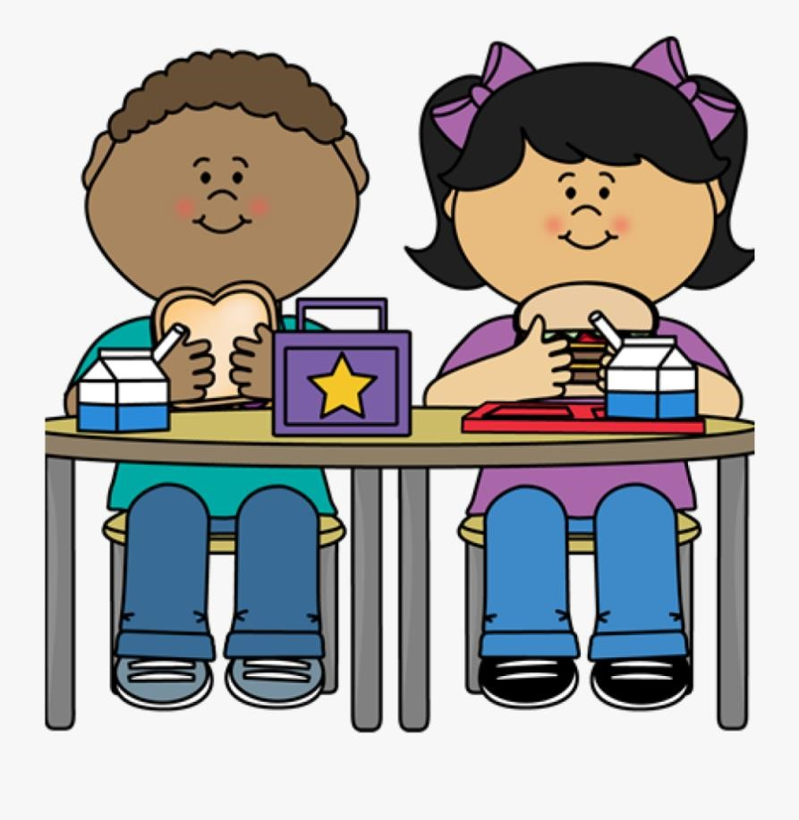
ADDITONAL MISCELLANEOUS INFORMATION

SCHOOL POLICIES

PLEASE NOTE - School policies can be accessed online at
www.bellaghyps.co.uk

Also, please download the school app from the App Store or Google Play, search for Bellaghy PS and download for free. Relevant policies can be accessed on the app. You will also find relevant forms and other information about our school.
If you are asked for an access code or PIN, type 11111.

BEHAVIOUR

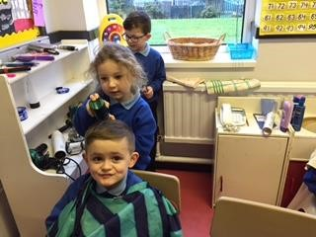
The standard of behaviour at Bellaghy Primary School is exemplary! We consistently encourage our children to have good manners and to be well behaved and obedient. We have a policy in our school where we reward good behaviour with what we call ‘Golden Time’ (a special play time) on
Friday afternoon. If a child
has repeatedly misbehaved, he / she will not have golden time. (Please see Behaviour Policy.)

ANTI-BULLYING

We strive to develop a culture in our school where any form of bullying is inacceptable. We aim to establish an atmosphere which encourages respect, trust, consideration, tolerance and sensitivity towards others. Any form of bullying will be investigated fully in accordance with the Anti-Bullying Policy.

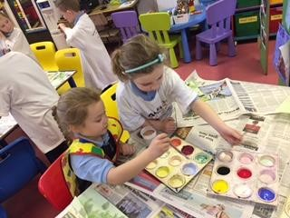
EQUALITY AND DIVERSITY

Bellaghy Primary School seeks to ensure that no member of the school community, or any person through their contact with the school, will receive less favourable treatment on the grounds of perceived or real difference
(protected characteristics). These include: race, colour, nationality, ethnic or national origin, religion or belief, gender, marital status, responsibility for children or other dependents, disability, sexual orientation, gender reassignment, age, trade union or political activities or socio-economic background.

SPECIAL EDUCATIONAL NEEDS
At our school, we are committed to providing equal access for all our pupils to the Northern Ireland Curriculum. We recognise that some pupils during their school career may have special educational needs and/or a disability. In the interests of these children, we will endeavour to make every reasonable arrangement to provide for their individual needs. If your child has a Special Educational Need, please inform the school without delay. (Please see SEN Policy.)

MOBILE PHONES / TABLETS

Our children have no requirement to have a mobile phone or personal
tablet at school. (Please see Use of Mobile Phone Policy.)

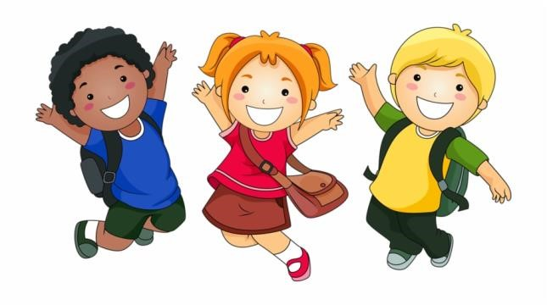

INTIMATE CARE

If your child has a little accident in school and does not get to the toilet on time, the teacher or classroom assistant will change him/her, two adults will be present. If you would prefer that your child is not changed, please inform the school in writing of your wishes. (Please see Intimate Care Policy.)

CHILD PROTECTION

Please remember, the safety and welfare of your child is our responsibility and if we have any concerns about his/her wellbeing, health or safety, we will liase with the relevant authorities. The Designated Teacher for Child Protection is Mrs Torrens and the
Designated Governor is Mrs Donnelly. (Please see Child Protection Policy.)

ADMINISTERING MEDICATION

If your child is unwell, he/she should not attend school. On occasion, parents request that the school should administer medication during the school day. In the event of the need for this, parents are asked to complete the relevant form on the School App – AM1, AM2 or AM3.

ABSENCE FROM SCHOOL

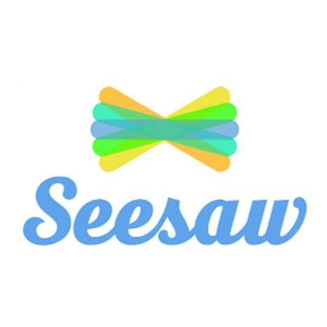
Attendance at school is very important and we strive to encourage good attendance and habits of punctuality from an early age. Please note school starts at 8.55am. If your child is going to be late for whatever reason, please phone the school. Following an absence, parents are asked to complete and submit an absence form, on the School App (under FORMS).

SEESAW (online learning app)

This is an online app which you can use on your Smartphone or tablet. Your child and staff will upload various items of interest for you to view online. These include photographs of your child in school, a nice piece of work or a recording of your child’s voice telling you something about his/her learning. It will also be used to assign homeworks or to facilitate home-learning in the event of unscheduled school closures. Please complete and submit the Seesaw Consent Form on the School App (under FORMS). Your child’s teacher will issue you with Seesaw log in details.

PHOTOGRAPHS

In school, we take photographs, record videos and voice overs etc to capture significant events and achievements etc. Sometimes, we place photographs or video footage on social media or on our school website. Consent is required for all photography related matters. You will find this consent on the School App under FORMS. (Please also see Photography Policy.)

DATA PROTECTION

We hold data on you and your child. We share data with some organisations. Please see the Privacy Statement on school website.

SOCIAL MEDIA

Our school has two Facebook pages:

Bellaghy Primary School – this is a private page and is only accessible by application if you are a parent, grandparent, past pupil, staff member or governor. Please send a member request and admin will authorise your request.

Bellaghy Primary School PTA – this page is open to anyone.

We have a shared Twitter page with St John Bosco Primary School.

TOYS

Children are discouraged from bringing toys to school as they sometimes get lost or broken. However, sometimes we ask children to bring things to school for display purpose or for a topic we are doing.

AFTER SCHOOL CLUBS

Children in P3 – P7 can attend after school clubs, for example, football, hockey, art, craft, cookery, movie, drama, choir etc. Most clubs are £1 - £2.

PARENT TEACHER INTERVIEWS
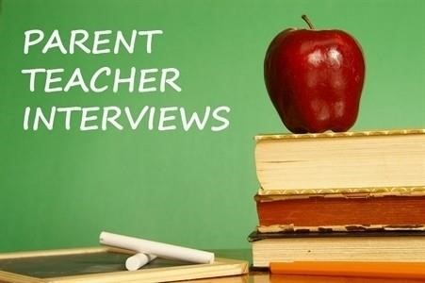

These are held in October/November and then again in February/March. We would encourage you to attend, to hear about your child’s progress at our school. You will receive a written Annual Report at the end of each school year in June.

HOMEWORK

Please check out the Homework Policy on the school website. This additional input at home can make such a positive contribution to your child’s progress at school. Some homework will be assigned and can be submitted on Seesaw.

LABELS

Please ensure ALL your child’s belongings are suitably labelled with his/her name. By the end of the school year, we usually accumulate an extensive collection of school sweatshirts!

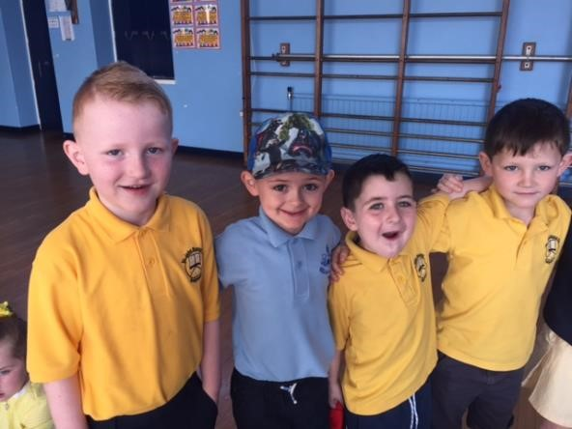
CROSS-COMMUNTY PARTNERSHIP

We have a cross-community partnership with St John Bosco Primary School. During the year, your child will be involved in shared activities with the children from St John Bosco.

WEEKLY NEWSLETTER

Each Friday, we publish a weekly news sheet, informing you of significant events in the week ahead. You will receive this Newsletter on Seesaw. It will also be posted on Facebook, on the school website and on the School App.

CORRESPONDENCE TO/FROM PARENTS

Most of the correspondence between home and school and vice versa can be done on Seesaw. You can message your child’s teacher on Seesaw but please remember, he/she may not respond immediately or outside of school hours. If you need to speak to a member of staff urgently, please phone the school – 79 386 419.

After a period of absence, please complete an Absence form on the School App, found under FORMS.

PARENT TEACHER ASSOCIATION (PTA)

Our dynamic Parent Teacher Association organises a variety of events every year to raise funds for our school. These events are always well supported and are enjoyed by the whole school family.

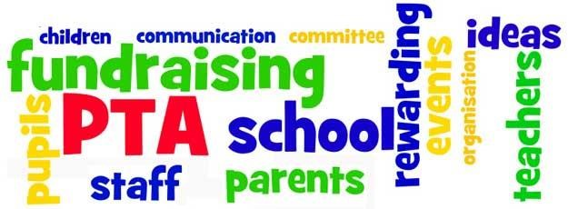
FORMS TO BE COMPLETED ON REGISTERING YOUR CHILD IN
BELLAGHY PRIMARY SCHOOL

Please go to the school app, complete and submit the following forms:

- Consent Form – this is a detailed consent form, please complete all parts;
- Seesaw Consent Form; • SIMS – Data Collection Form.

If you prefer a paper copy of these forms, please contact a member of staff and we will ensure you get what you need.

Thank-you!

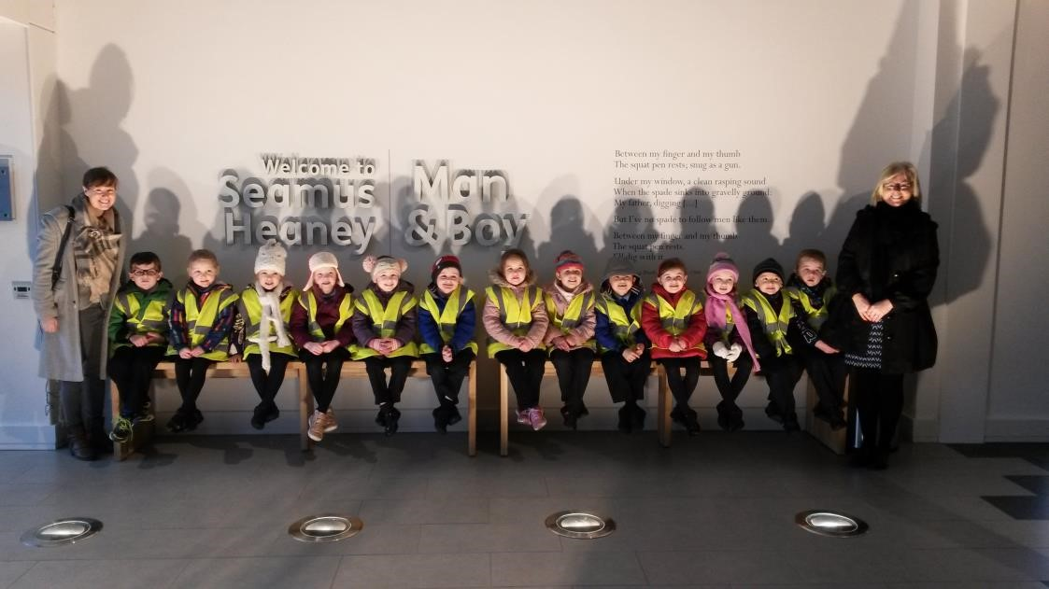

AND FINALLY . . .

We are confident that your child will be very happy at our school.
However, if you ever have any little worries or anxieties about your child or any aspect of his/her education, please make an appointment to speak to his/her teacher immediately.

Thank you for taking the time to read this information booklet and we look forward to teaching your child at Bellaghy Primary School.

CONTACT INFORMATION

PRINCIPAL: Mary-Lou Richmond EMAIL: mrichmond484@c2kni.net

SENIOR TEACHER: Judith Torrens EMAIL: jtorrens636@c2kni.net

TEL: 028 79 386 419

CHAIR of GOVERNORS: Timothy Dowie

